
Practical No.: 12
Aim –
Implement the jQuery library for DOM manipulation, event handling, animations, and LocalStorage integration to develop an interactive Task Manager application supporting persistent task creation, status toggling, and deletion. Implement Case Study 2: Beats & Beyond Online Music Concert Registration system with tier-based ticket selection, dynamic pricing updates, promo discounts, and real-time validation, along with Discover Nagpur City showcase featuring periodic DOM style animation (blinking effect) and responsive local attraction exploration.
Software/Tools Required –
VSCode
Chrome Browser
HTML5
CSS3
JavaScript (ES6)
jQuery Library (v3.7.1)
Experiment Program Code – Interactive Task Manager (jQuery & LocalStorage)
index.html
<!DOCTYPE html>
<html lang="en">
<head>
<meta charset="UTF-8">
<meta name="viewport" content="width=device-width, initial-scale=1.0">

<title>Interactive Task Manager</title>

<link rel="stylesheet" href="style.css">

<script src="https://code.jquery.com/jquery-3.7.1.min.js"></script>
</head>
<body>

<div class="container">

<h1>My Task Manager</h1>
<p class="subtitle">Organize your day, one task at a time.</p>

<div class="task-form">
<input
type="text"
id="taskInput"
placeholder="Enter a new task..."
>

<button id="addBtn">Add Task</button>
</div>

<div class="actions">
<button id="loadBtn">Load Sample Tasks</button>
<button id="clearBtn">Clear All Tasks</button>
</div>

<p id="message"></p>

<h2>My Tasks</h2>

<ul id="taskList"></ul>

<p id="taskCount">Total Tasks: 0</p>

</div>

<script src="script.js"></script>

</body>
</html>
style.css
* {
box-sizing: border-box;
}

body {
margin: 0;
padding: 20px;
font-family: Arial, sans-serif;
background: #edf3ff;
color: #263754;
}

.container {
max-width: 650px;
margin: 40px auto;
padding: 25px;
background: white;
border-radius: 14px;
box-shadow: 0 5px 20px rgba(0, 0, 0, 0.08);
}

h1 {
text-align: center;
color: #315fc4;
}

.subtitle {
text-align: center;
color: #64748b;
margin-bottom: 25px;
}

.task-form {
display: flex;
gap: 10px;
}

input {
flex: 1;
min-width: 0;
padding: 12px;
border: 1px solid #cbd5e1;
border-radius: 7px;
font-size: 15px;
}

button {
padding: 11px 15px;
border: none;
border-radius: 7px;
background: #315fc4;
color: white;
cursor: pointer;
font-size: 14px;
}

button:hover {
background: #23489b;
}

.actions {
display: flex;
gap: 10px;
margin-top: 15px;
flex-wrap: wrap;
}

#clearBtn {
background: #dc5353;
}

#clearBtn:hover {
background: #b83232;
}

#message {
min-height: 20px;
color: #315fc4;
margin-top: 15px;
}

h2 {
color: #315fc4;
margin-top: 25px;
}

#taskList {
list-style: none;
padding: 0;
}

#taskList li {
display: flex;
align-items: center;
justify-content: space-between;
gap: 10px;
padding: 12px;
margin: 10px 0;
background: #f3f6ff;
border-radius: 8px;
overflow-wrap: anywhere;
}

.task-text {
flex: 1;
}

.completed .task-text {
text-decoration: line-through;
color: #8993a5;
}

.task-buttons {
display: flex;
gap: 6px;
flex-shrink: 0;
}

.done-btn {
background: #25875a;
}

.delete-btn {
background: #dc5353;
}

#taskCount {
text-align: right;
color: #64748b;
font-weight: bold;
}

@media (max-width: 480px) {
.container {
margin: 10px auto;
padding: 17px;
}

.task-form {
flex-direction: column;
}

.task-buttons button {
padding: 9px;
}

#taskList li {
align-items: flex-start;
}
}
script.js
$(document).ready(function () {

let tasks = JSON.parse(
localStorage.getItem("myTasks") || "[]"
);

// Save tasks in localStorage
function saveTasks() {
localStorage.setItem(
"myTasks",
JSON.stringify(tasks)
);
}

// Display tasks on the webpage
function displayTasks() {

$("#taskList").empty();

if (tasks.length === 0) {
$("#taskList").append(
$("<li>").text("No tasks available.")
);
}

tasks.forEach(function (task) {

let li = $("<li>");

if (task.completed) {
li.addClass("completed");
}

let checkbox = $("<input>", {
type: "checkbox"
}).prop("checked", task.completed);

let text = $("<span>", {
class: "task-text"
}).text(task.title);

let doneButton = $("<button>", {
class: "done-btn",
text: task.completed ? "Undo" : "Done"
});

let deleteButton = $("<button>", {
class: "delete-btn",
text: "Delete"
});

let buttonBox = $("<div>", {
class: "task-buttons"
});

buttonBox.append(doneButton, deleteButton);

li.append(checkbox, text, buttonBox);

li.data("taskId", task.id);

$("#taskList").append(li);

});

$("#taskCount").text(
"Total Tasks: " + tasks.length +
" | Completed: " +
tasks.filter(function (task) {
return task.completed;
}).length
);

}

// Add a new task
function addTask(title) {

title = title.trim();

if (title === "") {
$("#message").text("Please enter a task.");
return;
}

tasks.push({
id: Date.now() + Math.random(),
title: title,
completed: false
});

saveTasks();
displayTasks();

$("#message").text("Task added successfully!");
$("#taskInput").val("");
}

$("#addBtn").on("click", function () {
addTask($("#taskInput").val());
});

// Add task by pressing Enter
$("#taskInput").on("keydown", function (event) {
if (event.key === "Enter") {
addTask($(this).val());
}
});

// Mark a task as completed or undo completion
$("#taskList").on("click", ".done-btn", function () {

let id = $(this).closest("li").data("taskId");

let task = tasks.find(function (item) {
return item.id === id;
});

if (task) {
task.completed = !task.completed;
saveTasks();
displayTasks();
}

});

// Checkbox event
$("#taskList").on("change", "input[type='checkbox']", function () {

let id = $(this).closest("li").data("taskId");

let task = tasks.find(function (item) {
return item.id === id;
});

if (task) {
task.completed = $(this).is(":checked");
saveTasks();
displayTasks();
}

});

// Delete a task
$("#taskList").on("click", ".delete-btn", function () {

let id = $(this).closest("li").data("taskId");

tasks = tasks.filter(function (task) {
return task.id !== id;
});

saveTasks();
displayTasks();

$("#message").text("Task deleted.");
});

// Clear all tasks
$("#clearBtn").on("click", function () {

tasks = [];

saveTasks();
displayTasks();

$("#message").text("All tasks cleared.");
});

// AJAX: Fetch sample tasks from an external API
$("#loadBtn").on("click", function () {

$("#message").text("Loading sample tasks...");

$.ajax({
url: "https://jsonplaceholder.typicode.com/todos?_limit=5",
method: "GET",
dataType: "json",

success: function (data) {

data.forEach(function (item) {

tasks.push({
id: Date.now() + Math.random(),
title: item.title,
completed: item.completed
});

});

saveTasks();
displayTasks();

$("#message").text(
"Sample tasks loaded successfully!"
);

},

error: function () {

$("#message").text(
"Unable to load tasks. Check your internet connection."
);

}
});

});

// Display saved tasks when the page opens
displayTasks();

});
Output –
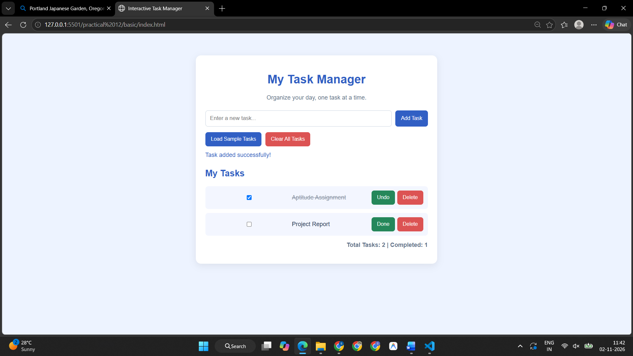
Case Study Title –
Case Study 2: Beats & Beyond Online Music Concert Pass Booking & Registration System
Case Study Program Code –
index.html
<!DOCTYPE html>
<html lang="en">
<head>
<meta charset="UTF-8">
<meta name="viewport" content="width=device-width, initial-scale=1.0">

<title>Beats & Beyond | Music Concert Registration</title>

<!-- Internal JavaScript - Practical 1 -->
<script>
console.log("Beats & Beyond registration page is loading...");

function welcomeConcertVisitor() {
console.log("Welcome to Beats & Beyond Music Festival!");
}

welcomeConcertVisitor();
</script>

<link rel="stylesheet" href="style.css">
</head>

<body>

<!-- ================= HEADER ================= -->

<header class="header">
<div class="logo">
<span class="logo-icon">♫</span>
<div>
<h2>BEATS<span>&</span>BEYOND</h2>
<small>LIVE MUSIC FESTIVAL</small>
</div>
</div>

<nav>
<a href="#event">Event</a>
<a href="#register">Register</a>
<a href="#summary">Summary</a>
</nav>

<button id="themeBtn" class="theme-btn" type="button">
🌙
</button>
</header>

<!-- ================= HERO ================= -->

<section class="hero" id="event">

<div class="hero-content">

<p class="event-label">THE BIGGEST MUSIC EXPERIENCE</p>

<h1>
BEATS
<span>&</span>
BEYOND
</h1>

<p class="hero-text">
One stage. Endless beats. One unforgettable night.
</p>

<div class="event-info">

<div>
<span>📅</span>
<strong>18 OCT 2026</strong>
<small>Sunday</small>
</div>

<div>
<span>📍</span>
<strong>Riverside Arena</strong>
<small>Mumbai, India</small>
</div>

<div>
<span>⏰</span>
<strong>5:00 PM onwards</strong>
<small>Gates open at 4 PM</small>
</div>

</div>

<a href="#register" class="hero-btn">
Get Your Pass →
</a>

</div>

<div class="hero-art">
<div class="vinyl">
<div class="vinyl-center">♫</div>
</div>

<div class="equalizer">
<i></i>
<i></i>
<i></i>
<i></i>
<i></i>
<i></i>
<i></i>
</div>
</div>

</section>

<!-- ================= ARTISTS ================= -->

<section class="artists">

<div class="section-heading">
<p>FEEL THE SOUND</p>
<h2>One Night. Multiple Vibes.</h2>
</div>

<div class="artist-grid">

<div class="artist-card">
<div class="artist-icon">🎤</div>
<h3>Live Performances</h3>
<p>Experience powerful live performances from emerging artists.</p>
</div>

<div class="artist-card">
<div class="artist-icon">🎸</div>
<h3>Rock & Indie</h3>
<p>High-energy guitar performances for every rock lover.</p>
</div>

<div class="artist-card">
<div class="artist-icon">🎧</div>
<h3>EDM Nights</h3>
<p>Electronic beats, lights and an unforgettable dance floor.</p>
</div>

<div class="artist-card">
<div class="artist-icon">🎶</div>
<h3>Bollywood Beats</h3>
<p>Your favourite Bollywood tracks performed live.</p>
</div>

</div>

</section>

<!-- ================= REGISTRATION ================= -->

<main class="main-container" id="register">

<div class="form-section">

<div class="section-heading left">
<p>SECURE YOUR ENTRY</p>
<h2>Concert Registration</h2>
<span>
Fill in your details and customize your concert experience.
</span>
</div>

<form id="concertForm" novalidate>

<!-- PERSONAL DETAILS -->

<div class="form-card">

<div class="card-title">
<span>01</span>
<div>
<h3>Personal Details</h3>
<p>Tell us who is joining the concert.</p>
</div>
</div>

<div class="form-grid">

<div class="field">
<label for="fullName">Full Name *</label>
<input
type="text"
id="fullName"
placeholder="Enter your full name"
>
<small class="error" id="nameError"></small>
</div>

<div class="field">
<label for="email">Email Address *</label>
<input
type="email"
id="email"
placeholder="you@example.com"
>
<small class="error" id="emailError"></small>
</div>

<div class="field">
<label for="phone">Mobile Number *</label>
<input
type="tel"
id="phone"
placeholder="10-digit mobile number"
maxlength="10"
>
<small class="error" id="phoneError"></small>
</div>

<div class="field">
<label for="age">Age *</label>
<input
type="number"
id="age"
min="16"
max="80"
placeholder="Enter your age"
>
<small class="error" id="ageError"></small>
</div>

</div>

</div>

<!-- TICKET DETAILS -->

<div class="form-card">

<div class="card-title">
<span>02</span>
<div>
<h3>Choose Your Pass</h3>
<p>Select the experience you want.</p>
</div>
</div>

<div class="ticket-grid">

<label class="ticket-card">

<input
type="radio"
name="ticket"
value="General Admission"
data-price="799"
checked
>

<div class="ticket-content">
<div class="ticket-top">
<h3>General</h3>
<strong>₹799</strong>
</div>

<p>Concert entry + standard seating area</p>

<ul>
<li>✓ Main stage access</li>
<li>✓ Food court access</li>
</ul>
</div>

</label>

<label class="ticket-card">

<input
type="radio"
name="ticket"
value="VIP Pass"
data-price="1799"
>

<div class="ticket-content">
<div class="ticket-top">
<h3>VIP</h3>
<strong>₹1,799</strong>
</div>

<p>Premium experience with priority access</p>

<ul>
<li>✓ Priority entry</li>
<li>✓ VIP lounge</li>
</ul>
</div>

</label>

<label class="ticket-card">

<input
type="radio"
name="ticket"
value="Backstage Pass"
data-price="2999"
>

<div class="ticket-content">
<div class="ticket-top">
<h3>Backstage</h3>
<strong>₹2,999</strong>
</div>

<p>Exclusive access behind the stage</p>

<ul>
<li>✓ Backstage access</li>
<li>✓ Artist meet & greet</li>
</ul>
</div>

</label>

</div>

<div class="quantity-row">

<div class="field small-field">
<label for="quantity">Number of Passes *</label>

<select id="quantity">
<option value="1">1 Pass</option>
<option value="2">2 Passes</option>
<option value="3">3 Passes</option>
<option value="4">4 Passes</option>
<option value="5">5 Passes</option>
</select>
</div>

<div class="field">
<label for="musicGenre">Favourite Music Genre *</label>

<select id="musicGenre">
<option value="">Select a genre</option>
<option value="Pop">Pop</option>
<option value="Rock">Rock</option>
<option value="EDM">EDM</option>
<option value="Bollywood">Bollywood</option>
<option value="Indie">Indie</option>
<option value="Hip-Hop">Hip-Hop</option>
</select>

<small class="error" id="genreError"></small>
</div>

</div>

</div>

<!-- ADD-ONS -->

<div class="form-card">

<div class="card-title">
<span>03</span>
<div>
<h3>Make It Special</h3>
<p>Add something extra to your concert experience.</p>
</div>
</div>

<div class="addon-grid">

<label class="addon">
<input
type="checkbox"
class="addon-check"
value="Concert Merchandise"
data-price="499"
>

<span class="addon-icon">👕</span>

<div>
<strong>Concert Merchandise</strong>
<small>₹499</small>
</div>
</label>

<label class="addon">
<input
type="checkbox"
class="addon-check"
value="Meal Voucher"
data-price="299"
>

<span class="addon-icon">🍔</span>

<div>
<strong>Meal Voucher</strong>
<small>₹299</small>
</div>
</label>

<label class="addon">
<input
type="checkbox"
class="addon-check"
value="Meet & Greet"
data-price="999"
>

<span class="addon-icon">🤝</span>

<div>
<strong>Meet & Greet</strong>
<small>₹999</small>
</div>
</label>

<label class="addon">
<input
type="checkbox"
class="addon-check"
value="Photo Booth"
data-price="199"
>

<span class="addon-icon">📸</span>

<div>
<strong>Photo Booth</strong>
<small>₹199</small>
</div>
</label>

</div>

</div>

<!-- ATTENDEE DETAILS -->

<div class="form-card">

<div class="card-title">
<span>04</span>
<div>
<h3>Friends Joining?</h3>
<p>Add the names of people attending with you.</p>
</div>
</div>

<div class="attendee-input">

<input
type="text"
id="attendeeName"
placeholder="Enter attendee name"
>

<button
type="button"
id="addAttendeeBtn"
class="secondary-btn"
>
+ Add
</button>

</div>

<div id="attendeeList" class="attendee-list"></div>

</div>

<!-- FOOD + PROMO -->

<div class="form-card">

<div class="card-title">
<span>05</span>
<div>
<h3>Final Preferences</h3>
<p>Almost there!</p>
</div>
</div>

<div class="form-grid">

<div class="field">
<label for="foodPreference">Food Preference</label>

<select id="foodPreference">
<option value="No Preference">No Preference</option>
<option value="Vegetarian">Vegetarian</option>
<option value="Non-Vegetarian">Non-Vegetarian</option>
<option value="Vegan">Vegan</option>
</select>
</div>

<div class="field">

<label for="promoCode">
Promo Code
</label>

<div class="promo-input">
<input
type="text"
id="promoCode"
placeholder="Enter promo code"
>

<button
type="button"
id="applyPromoBtn"
>
Apply
</button>
</div>

<small id="promoMessage"></small>

</div>

</div>

<label class="terms">
<input type="checkbox" id="terms">
<span>
I agree to the event terms and understand that
tickets are non-refundable. *
</span>
</label>

<small class="error" id="termsError"></small>

</div>

<!-- ACTIONS -->

<div class="form-actions">

<button
type="reset"
class="reset-btn"
id="resetBtn"
>
Reset
</button>

<button
type="submit"
class="submit-btn"
>
Complete Registration →
</button>

</div>

</form>

</div>

<!-- ================= SUMMARY ================= -->

<aside class="summary-card" id="summary">

<div class="summary-header">
<div>
<p>YOUR EXPERIENCE</p>
<h2>Booking Summary</h2>
</div>

<span class="summary-icon">🎵</span>
</div>

<div class="summary-event">
<strong>BEATS & BEYOND</strong>
<span>18 October 2026 • Riverside Arena</span>
</div>

<div id="summaryContent">

<div class="summary-row">
<span>Pass</span>
<strong id="summaryTicket">
General Admission
</strong>
</div>

<div class="summary-row">
<span>Quantity</span>
<strong id="summaryQuantity">1</strong>
</div>

<div class="summary-row">
<span>Genre</span>
<strong id="summaryGenre">Not selected</strong>
</div>

<div class="summary-row">
<span>Extras</span>
<strong id="summaryAddons">None</strong>
</div>

<div class="summary-row">
<span>Discount</span>
<strong id="summaryDiscount">₹0</strong>
</div>

</div>

<div class="total-box">
<span>Total Amount</span>
<strong id="summaryTotal">₹799</strong>
</div>

<p class="secure-text">
🔒 Your registration details are handled securely.
</p>

</aside>

</main>

<!-- ================= CONFIRMATION MODAL ================= -->

<div class="modal-overlay" id="confirmationModal">

<div class="modal">

<button
class="close-modal"
id="closeModalBtn"
type="button"
>
×
</button>

<div class="success-icon">✓</div>

<p class="modal-label">REGISTRATION CONFIRMED</p>

<h2>You're on the guest list! 🎉</h2>

<p id="confirmationText">
Your concert registration has been successfully completed.
</p>

<div class="registration-id">
<span>Registration ID</span>
<strong id="registrationId">BB-000001</strong>
</div>

<button
type="button"
class="modal-btn"
id="doneBtn"
>
Done
</button>

</div>

</div>

<!-- External JavaScript - Practical 1 -->
<script src="script.js"></script>

</body>
</html>
style.css
/* =====================================================
BEATS & BEYOND
ONLINE MUSIC CONCERT REGISTRATION
===================================================== */

:root {
--bg: #f7f4ff;
--surface: #ffffff;
--surface-2: #f1edff;
--text: #191522;
--muted: #706b7d;
--primary: #7547ff;
--primary-dark: #5a2fd1;
--accent: #ff4fa3;
--border: #e5e0ef;
--success: #159957;
--danger: #e5395a;
--shadow: 0 18px 50px rgba(49, 30, 90, 0.10);
}

* {
box-sizing: border-box;
margin: 0;
padding: 0;
}

html {
scroll-behavior: smooth;
}

body {
font-family: "Segoe UI", Arial, sans-serif;
background: var(--bg);
color: var(--text);
line-height: 1.6;
transition: background 0.3s, color 0.3s;
}

body.dark {
--bg: #100d18;
--surface: #1b1725;
--surface-2: #252031;
--text: #f8f6ff;
--muted: #aaa3b8;
--border: #373044;
--shadow: 0 18px 50px rgba(0, 0, 0, 0.35);
}

/* ================= HEADER ================= */

.header {
height: 76px;
padding: 0 6%;
background: var(--surface);
border-bottom: 1px solid var(--border);

display: flex;
align-items: center;
justify-content: space-between;

position: sticky;
top: 0;
z-index: 1000;
}

.logo {
display: flex;
align-items: center;
gap: 10px;
}

.logo-icon {
width: 40px;
height: 40px;
border-radius: 12px;

display: grid;
place-items: center;

background: var(--primary);
color: white;

font-size: 23px;
font-weight: bold;
}

.logo h2 {
font-size: 17px;
letter-spacing: 1px;
}

.logo h2 span {
color: var(--accent);
}

.logo small {
display: block;
font-size: 8px;
letter-spacing: 2px;
color: var(--muted);
}

nav {
display: flex;
gap: 28px;
}

nav a {
text-decoration: none;
color: var(--muted);
font-size: 14px;
font-weight: 600;
}

nav a:hover {
color: var(--primary);
}

.theme-btn {
border: 1px solid var(--border);
background: var(--surface-2);
color: var(--text);

width: 40px;
height: 40px;
border-radius: 12px;

cursor: pointer;
font-size: 18px;
}

/* ================= HERO ================= */

.hero {
min-height: 570px;
padding: 75px 8%;

background:
radial-gradient(circle at 80% 20%, rgba(117, 71, 255, 0.28), transparent 35%),
radial-gradient(circle at 20% 80%, rgba(255, 79, 163, 0.18), transparent 30%),
var(--surface);

display: flex;
align-items: center;
justify-content: space-between;

overflow: hidden;
}

.hero-content {
max-width: 650px;
}

.event-label,
.section-heading p,
.modal-label {
color: var(--accent);
font-size: 12px;
letter-spacing: 3px;
font-weight: 800;
}

.hero h1 {
font-size: clamp(58px, 9vw, 120px);
line-height: 0.9;
letter-spacing: -5px;
margin: 15px 0 25px;
}

.hero h1 span {
color: var(--primary);
}

.hero-text {
color: var(--muted);
font-size: 19px;
max-width: 500px;
}

.event-info {
display: flex;
gap: 20px;
margin: 35px 0;
flex-wrap: wrap;
}

.event-info div {
padding-right: 20px;
border-right: 1px solid var(--border);

display: flex;
flex-direction: column;
}

.event-info div:last-child {
border-right: none;
}

.event-info span {
font-size: 20px;
}

.event-info strong {
font-size: 14px;
margin-top: 4px;
}

.event-info small {
color: var(--muted);
font-size: 12px;
}

.hero-btn {
display: inline-block;
padding: 14px 25px;
border-radius: 12px;

background: var(--primary);
color: white;

text-decoration: none;
font-weight: 700;

transition: 0.25s;
}

.hero-btn:hover {
background: var(--primary-dark);
transform: translateY(-2px);
}

/* ================= HERO ART ================= */

.hero-art {
width: 380px;
height: 380px;

display: grid;
place-items: center;

position: relative;
}

.vinyl {
width: 310px;
height: 310px;
border-radius: 50%;

background:
repeating-radial-gradient(
circle,
#18131f 0px,
#18131f 7px,
#251d2d 8px,
#18131f 11px
);

box-shadow: 0 30px 60px rgba(0, 0, 0, 0.25);

display: grid;
place-items: center;
}

.vinyl-center {
width: 100px;
height: 100px;
border-radius: 50%;

background: linear-gradient(
135deg,
var(--primary),
var(--accent)
);

display: grid;
place-items: center;

color: white;
font-size: 42px;
}

.equalizer {
position: absolute;
bottom: 15px;
display: flex;
gap: 7px;
align-items: end;
}

.equalizer i {
display: block;
width: 7px;
border-radius: 5px;
background: var(--accent);
}

.equalizer i:nth-child(1) { height: 25px; }
.equalizer i:nth-child(2) { height: 50px; }
.equalizer i:nth-child(3) { height: 80px; }
.equalizer i:nth-child(4) { height: 110px; }
.equalizer i:nth-child(5) { height: 65px; }
.equalizer i:nth-child(6) { height: 40px; }
.equalizer i:nth-child(7) { height: 25px; }

/* ================= ARTISTS ================= */

.artists {
padding: 80px 8%;
background: var(--bg);
}

.section-heading {
text-align: center;
margin-bottom: 40px;
}

.section-heading h2 {
font-size: 36px;
margin-top: 6px;
}

.section-heading span {
color: var(--muted);
}

.section-heading.left {
text-align: left;
}

.artist-grid {
max-width: 1200px;
margin: auto;

display: grid;
grid-template-columns: repeat(4, 1fr);
gap: 18px;
}

.artist-card {
padding: 28px;
background: var(--surface);

border: 1px solid var(--border);
border-radius: 20px;

transition: 0.25s;
}

.artist-card:hover {
transform: translateY(-5px);
box-shadow: var(--shadow);
}

.artist-icon {
font-size: 35px;
margin-bottom: 15px;
}

.artist-card h3 {
margin-bottom: 8px;
}

.artist-card p {
color: var(--muted);
font-size: 13px;
}

/* ================= MAIN ================= */

.main-container {
max-width: 1300px;
margin: auto;
padding: 70px 5%;

display: grid;
grid-template-columns: minmax(0, 1fr) 360px;
gap: 30px;
}

.form-section {
min-width: 0;
}

/* ================= FORM CARD ================= */

.form-card {
background: var(--surface);
border: 1px solid var(--border);
border-radius: 20px;

padding: 30px;
margin-bottom: 20px;

box-shadow: 0 8px 30px rgba(50, 30, 90, 0.04);
}

.card-title {
display: flex;
gap: 15px;
align-items: center;
margin-bottom: 25px;
}

.card-title > span {
width: 38px;
height: 38px;
border-radius: 10px;

display: grid;
place-items: center;

background: var(--surface-2);
color: var(--primary);
font-weight: 800;
}

.card-title h3 {
font-size: 18px;
}

.card-title p {
color: var(--muted);
font-size: 12px;
}

/* ================= FORM ================= */

.form-grid {
display: grid;
grid-template-columns: repeat(2, 1fr);
gap: 18px;
}

.field {
display: flex;
flex-direction: column;
gap: 7px;
}

.field label {
font-size: 13px;
font-weight: 700;
}

.field input,
.field select,
.attendee-input input,
.promo-input input {
width: 100%;
height: 46px;

padding: 0 14px;

border: 1px solid var(--border);
border-radius: 10px;

background: var(--bg);
color: var(--text);

outline: none;
font: inherit;
}

.field input:focus,
.field select:focus,
.attendee-input input:focus,
.promo-input input:focus {
border-color: var(--primary);
box-shadow: 0 0 0 3px rgba(117, 71, 255, 0.10);
}

.field input.valid {
border-color: var(--success);
}

.field input.invalid,
.field select.invalid {
border-color: var(--danger);
}

.error {
color: var(--danger);
font-size: 11px;
min-height: 15px;
}

/* ================= TICKETS ================= */

.ticket-grid {
display: grid;
grid-template-columns: repeat(3, 1fr);
gap: 15px;
}

.ticket-card {
position: relative;
cursor: pointer;
}

.ticket-card input {
position: absolute;
opacity: 0;
}

.ticket-content {
height: 100%;
padding: 20px;

border: 2px solid var(--border);
border-radius: 15px;

background: var(--bg);

transition: 0.2s;
}

.ticket-card input:checked + .ticket-content {
border-color: var(--primary);
background: var(--surface-2);
}

.ticket-top {
display: flex;
justify-content: space-between;
gap: 10px;
}

.ticket-top strong {
color: var(--primary);
}

.ticket-content p {
color: var(--muted);
font-size: 12px;
margin: 10px 0;
}

.ticket-content ul {
list-style: none;
font-size: 11px;
color: var(--muted);
}

.quantity-row {
display: grid;
grid-template-columns: 1fr 1fr;
gap: 18px;
margin-top: 20px;
}

/* ================= ADDONS ================= */

.addon-grid {
display: grid;
grid-template-columns: repeat(2, 1fr);
gap: 12px;
}

.addon {
display: flex;
align-items: center;
gap: 12px;

padding: 16px;

border: 1px solid var(--border);
border-radius: 14px;

cursor: pointer;
background: var(--bg);
}

.addon:hover {
border-color: var(--primary);
}

.addon-check {
accent-color: var(--primary);
}

.addon-icon {
font-size: 25px;
}

.addon div {
display: flex;
flex-direction: column;
}

.addon strong {
font-size: 13px;
}

.addon small {
color: var(--muted);
}

/* ================= ATTENDEES ================= */

.attendee-input {
display: flex;
gap: 10px;
}

.secondary-btn,
#applyPromoBtn {
border: none;
background: var(--primary);
color: white;

padding: 0 20px;
border-radius: 10px;

cursor: pointer;
font-weight: 700;
}

.attendee-list {
margin-top: 15px;
display: flex;
flex-direction: column;
gap: 8px;
}

.attendee-item {
display: flex;
justify-content: space-between;
align-items: center;

padding: 10px 13px;

background: var(--surface-2);
border-radius: 10px;

font-size: 13px;
}

.attendee-actions {
display: flex;
gap: 6px;
}

.attendee-actions button {
border: none;
background: transparent;
cursor: pointer;
font-size: 13px;
}

/* ================= PROMO ================= */

.promo-input {
display: flex;
gap: 8px;
}

.promo-input input {
flex: 1;
}

#promoMessage {
font-size: 11px;
min-height: 15px;
}

.promo-success {
color: var(--success);
}

.promo-error {
color: var(--danger);
}

/* ================= TERMS ================= */

.terms {
margin-top: 20px;
display: flex;
align-items: flex-start;
gap: 10px;

font-size: 12px;
color: var(--muted);
}

.terms input {
margin-top: 4px;
accent-color: var(--primary);
}

/* ================= ACTIONS ================= */

.form-actions {
display: flex;
justify-content: flex-end;
gap: 12px;
}

.reset-btn,
.submit-btn {
padding: 14px 22px;
border-radius: 11px;
cursor: pointer;
font-weight: 700;
}

.reset-btn {
border: 1px solid var(--border);
background: var(--surface);
color: var(--text);
}

.submit-btn {
border: none;
background: linear-gradient(
135deg,
var(--primary),
var(--accent)
);
color: white;
}

/* ================= SUMMARY ================= */

.summary-card {
height: fit-content;

position: sticky;
top: 100px;

background: var(--surface);
border: 1px solid var(--border);
border-radius: 20px;

padding: 25px;
box-shadow: var(--shadow);
}

.summary-header {
display: flex;
justify-content: space-between;
align-items: center;
}

.summary-header p {
color: var(--accent);
font-size: 10px;
letter-spacing: 2px;
font-weight: 800;
}

.summary-header h2 {
font-size: 21px;
}

.summary-icon {
font-size: 28px;
}

.summary-event {
padding: 18px 0;
margin: 18px 0;

border-top: 1px solid var(--border);
border-bottom: 1px solid var(--border);

display: flex;
flex-direction: column;
}

.summary-event strong {
font-size: 13px;
}

.summary-event span {
color: var(--muted);
font-size: 11px;
}

.summary-row {
display: flex;
justify-content: space-between;
gap: 15px;

padding: 10px 0;

font-size: 12px;
}

.summary-row span {
color: var(--muted);
}

.summary-row strong {
text-align: right;
}

.total-box {
margin-top: 20px;
padding: 18px;

border-radius: 14px;

background: var(--surface-2);

display: flex;
justify-content: space-between;
align-items: center;
}

.total-box span {
font-size: 13px;
color: var(--muted);
}

.total-box strong {
font-size: 24px;
color: var(--primary);
}

.secure-text {
text-align: center;
color: var(--muted);
font-size: 10px;
margin-top: 15px;
}

/* ================= MODAL ================= */

.modal-overlay {
position: fixed;
inset: 0;

background: rgba(10, 5, 20, 0.65);

display: none;
align-items: center;
justify-content: center;

padding: 20px;
z-index: 2000;
}

.modal-overlay.show {
display: flex;
}

.modal {
position: relative;

width: min(450px, 100%);

padding: 40px 30px;

border-radius: 25px;

background: var(--surface);

text-align: center;
box-shadow: var(--shadow);
}

.close-modal {
position: absolute;
right: 18px;
top: 15px;

border: none;
background: transparent;

color: var(--muted);
font-size: 28px;

cursor: pointer;
}

.success-icon {
width: 65px;
height: 65px;

margin: auto auto 20px;

display: grid;
place-items: center;

border-radius: 50%;

background: rgba(21, 153, 87, 0.12);
color: var(--success);

font-size: 30px;
font-weight: bold;
}

.modal h2 {
margin: 10px 0;
font-size: 28px;
}

.modal p {
color: var(--muted);
font-size: 13px;
}

.registration-id {
margin: 25px 0;
padding: 15px;

background: var(--surface-2);
border-radius: 12px;

display: flex;
flex-direction: column;
}

.registration-id span {
color: var(--muted);
font-size: 10px;
text-transform: uppercase;
letter-spacing: 1px;
}

.registration-id strong {
color: var(--primary);
font-size: 20px;
}

.modal-btn {
border: none;
background: var(--primary);
color: white;

padding: 12px 35px;
border-radius: 10px;

cursor: pointer;
font-weight: 700;
}

/* ================= RESPONSIVE ================= */

@media (max-width: 1000px) {

.hero {
padding: 60px 6%;
}

.hero-art {
width: 300px;
height: 300px;
}

.vinyl {
width: 250px;
height: 250px;
}

.artist-grid {
grid-template-columns: repeat(2, 1fr);
}

.main-container {
grid-template-columns: 1fr;
}

.summary-card {
position: relative;
top: 0;
order: -1;
}
}

@media (max-width: 700px) {

.header {
padding: 0 4%;
}

nav {
display: none;
}

.hero {
min-height: auto;
padding: 60px 6%;
flex-direction: column;
text-align: center;
}

.hero h1 {
font-size: 60px;
letter-spacing: -3px;
}

.hero-text {
margin: auto;
}

.event-info {
justify-content: center;
}

.hero-art {
margin-top: 30px;
}

.artist-grid,
.ticket-grid,
.addon-grid,
.form-grid,
.quantity-row {
grid-template-columns: 1fr;
}

.form-card {
padding: 20px;
}

.attendee-input {
flex-direction: column;
}

.secondary-btn {
height: 45px;
}

.form-actions {
flex-direction: column-reverse;
}

.reset-btn,
.submit-btn {
width: 100%;
}
}
script.js
/* =====================================================
BEATS & BEYOND
ONLINE MUSIC CONCERT REGISTRATION

Concepts covered:
Practical 1 -> JS types, console
Practical 2 -> var, let, const, template literals,
destructuring, calculations
Practical 3 -> conditions and validation
Practical 4 -> functions, scope, closures, try-catch
Practical 5 -> arrays, objects, map/filter/find/reduce
Practical 6 -> strings and regular expressions
Practical 7 -> DOM manipulation
Practical 8 -> events
Practical 9 -> localStorage/sessionStorage
===================================================== */

/* =====================================================
PRACTICAL 1
CONSOLE METHODS + APPLICATION INFORMATION
===================================================== */

console.log("Beats & Beyond JavaScript loaded successfully.");

console.info("Concert registration system initialized.");

const applicationInfo = {
name: "Beats & Beyond",
type: "Online Music Concert Registration",
year: 2026
};

console.table(applicationInfo);

/* =====================================================
PRACTICAL 2
var, let, const
===================================================== */

const concertName = "BEATS & BEYOND";
const concertDate = "18 October 2026";

let appliedPromo = null;
let discount = 0;

/*
var is intentionally used here as part of the
JavaScript concepts learned in Practical 2.
*/
var registrationCount = 0;

/* =====================================================
DATA ARRAYS AND OBJECTS
PRACTICAL 5
===================================================== */

const ticketTypes = [
{
name: "General Admission",
price: 799
},
{
name: "VIP Pass",
price: 1799
},
{
name: "Backstage Pass",
price: 2999
}
];

const promoCodes = [
{
code: "BEATS10",
discount: 10
},
{
code: "MUSIC20",
discount: 20
},
{
code: "VIP15",
discount: 15
}
];

let attendees = [];

/* =====================================================
CLOSURE
PRACTICAL 4
===================================================== */

function createRegistrationIdGenerator() {

let counter =
Number(localStorage.getItem("concertRegistrationCounter")) || 0;

return function () {

counter++;

localStorage.setItem(
"concertRegistrationCounter",
counter
);

return `BB-${String(counter).padStart(6, "0")}`;
};
}

const generateRegistrationId =
createRegistrationIdGenerator();

/* =====================================================
DOM REFERENCES
PRACTICAL 7
===================================================== */

const form = document.getElementById("concertForm");

const nameInput = document.getElementById("fullName");
const emailInput = document.getElementById("email");
const phoneInput = document.getElementById("phone");
const ageInput = document.getElementById("age");

const quantityInput =
document.getElementById("quantity");

const genreInput =
document.getElementById("musicGenre");

const foodInput =
document.getElementById("foodPreference");

const attendeeInput =
document.getElementById("attendeeName");

const attendeeList =
document.getElementById("attendeeList");

const addAttendeeBtn =
document.getElementById("addAttendeeBtn");

const promoInput =
document.getElementById("promoCode");

const applyPromoBtn =
document.getElementById("applyPromoBtn");

const promoMessage =
document.getElementById("promoMessage");

const termsInput =
document.getElementById("terms");

const themeBtn =
document.getElementById("themeBtn");

const modal =
document.getElementById("confirmationModal");

const closeModalBtn =
document.getElementById("closeModalBtn");

const doneBtn =
document.getElementById("doneBtn");

/* =====================================================
SUMMARY REFERENCES
===================================================== */

const summaryTicket =
document.getElementById("summaryTicket");

const summaryQuantity =
document.getElementById("summaryQuantity");

const summaryGenre =
document.getElementById("summaryGenre");

const summaryAddons =
document.getElementById("summaryAddons");

const summaryDiscount =
document.getElementById("summaryDiscount");

const summaryTotal =
document.getElementById("summaryTotal");

/* =====================================================
PRACTICAL 6
REGULAR EXPRESSIONS
===================================================== */

const nameRegex =
/^[A-Za-z]+(?:[ '-][A-Za-z]+)*$/;

const emailRegex =
/^[^\s@]+@[^\s@]+\.[^\s@]{2,}$/;

const phoneRegex =
/^[6-9]\d{9}$/;

/* =====================================================
THEME
PRACTICAL 9
localStorage
===================================================== */

function loadTheme() {

const savedTheme =
localStorage.getItem("concertTheme");

if (savedTheme === "dark") {

document.body.classList.add("dark");

themeBtn.textContent = "☀️";

} else {

themeBtn.textContent = "🌙";
}
}

themeBtn.addEventListener("click", () => {

document.body.classList.toggle("dark");

const darkMode =
document.body.classList.contains("dark");

localStorage.setItem(
"concertTheme",
darkMode ? "dark" : "light"
);

themeBtn.textContent =
darkMode ? "☀️" : "🌙";

console.log(
`Theme changed to ${darkMode ? "dark" : "light"} mode.`
);
});

loadTheme();

/* =====================================================
VALIDATION FUNCTIONS
PRACTICAL 3 + PRACTICAL 6
===================================================== */

function showError(input, errorId, message) {

input.classList.add("invalid");
input.classList.remove("valid");

document.getElementById(errorId).textContent =
message;
}

const showSuccess = function (input, errorId) {

input.classList.remove("invalid");
input.classList.add("valid");

document.getElementById(errorId).textContent =
"";
};

function validateName() {

const value = nameInput.value.trim();

if (value === "") {

showError(
nameInput,
"nameError",
"Please enter your name."
);

return false;
}

if (!nameRegex.test(value)) {

showError(
nameInput,
"nameError",
"Please enter a valid name."
);

return false;
}

showSuccess(nameInput, "nameError");

return true;
}

function validateEmail() {

const value =
emailInput.value.trim().toLowerCase();

if (value === "") {

showError(
emailInput,
"emailError",
"Email is required."
);

return false;
}

if (!emailRegex.test(value)) {

showError(
emailInput,
"emailError",
"Enter a valid email address."
);

return false;
}

showSuccess(emailInput, "emailError");

return true;
}

function validatePhone() {

const value =
phoneInput.value.trim();

if (!phoneRegex.test(value)) {

showError(
phoneInput,
"phoneError",
"Enter a valid 10-digit mobile number."
);

return false;
}

showSuccess(phoneInput, "phoneError");

return true;
}

function validateAge() {

const age = Number(ageInput.value);

if (
age < 16 ||
age > 80 ||
ageInput.value === ""
) {

showError(
ageInput,
"ageError",
"Age must be between 16 and 80."
);

return false;
}

showSuccess(ageInput, "ageError");

return true;
}

function validateGenre() {

if (genreInput.value === "") {

showError(
genreInput,
"genreError",
"Please select your favourite genre."
);

return false;
}

genreInput.classList.remove("invalid");

return true;
}

function validateTerms() {

const errorBox =
document.getElementById("termsError");

if (!termsInput.checked) {

errorBox.textContent =
"Please accept the event terms.";

return false;
}

errorBox.textContent = "";

return true;
}

/* =====================================================
EVENTS
PRACTICAL 8
focus + blur
===================================================== */

nameInput.addEventListener("focus", () => {

console.log("Name field focused.");
});

nameInput.addEventListener("blur", validateName);

emailInput.addEventListener("blur", validateEmail);

phoneInput.addEventListener("blur", validatePhone);

ageInput.addEventListener("blur", validateAge);

/* =====================================================
INPUT EVENTS
PRACTICAL 8
===================================================== */

nameInput.addEventListener("input", () => {

nameInput.value =
nameInput.value.replace(/[0-9]/g, "");

validateName();

saveSessionData();
});

emailInput.addEventListener("input", () => {

validateEmail();

saveSessionData();
});

phoneInput.addEventListener("input", () => {

phoneInput.value =
phoneInput.value.replace(/\D/g, "");

validatePhone();

saveSessionData();
});

ageInput.addEventListener("input", () => {

validateAge();

saveSessionData();
});

/* =====================================================
TICKET SELECTION
PRACTICAL 5 + PRACTICAL 8
===================================================== */

const ticketInputs =
document.querySelectorAll(
'input[name="ticket"]'
);

ticketInputs.forEach(ticket => {

ticket.addEventListener("change", () => {

discount = 0;
appliedPromo = null;

promoMessage.textContent = "";

updateSummary();

saveSessionData();

console.log(
`Ticket changed to ${ticket.value}.`
);
});

});

/* =====================================================
OTHER CHANGE EVENTS
===================================================== */

quantityInput.addEventListener("change", () => {

updateSummary();
saveSessionData();
});

genreInput.addEventListener("change", () => {

validateGenre();
updateSummary();
saveSessionData();
});

foodInput.addEventListener("change", () => {

saveSessionData();

console.log(
`Food preference: ${foodInput.value}`
);
});

/* =====================================================
ADD-ON LOGIC
PRACTICAL 5
filter + map + reduce
===================================================== */

function getSelectedAddons() {

const selected =
document.querySelectorAll(
".addon-check:checked"
);

return [...selected].map(addon => ({

name: addon.value,

price: Number(addon.dataset.price)

}));
}

function calculateAddonTotal() {

const addons =
getSelectedAddons();

return addons.reduce(
(total, addon) => total + addon.price,
0
);
}

document
.querySelectorAll(".addon-check")
.forEach(addon => {

addon.addEventListener(
"change",
() => {

updateSummary();
saveSessionData();
}
);

});

/* =====================================================
FIND SELECTED TICKET
PRACTICAL 5
find()
===================================================== */

function getSelectedTicket() {

const selected =
document.querySelector(
'input[name="ticket"]:checked'
);

return ticketTypes.find(
ticket => ticket.name === selected.value
);
}

/* =====================================================
SUMMARY CALCULATION
PRACTICAL 2 + PRACTICAL 5
===================================================== */

function updateSummary() {

const selectedTicket =
getSelectedTicket();

/*
Destructuring
Practical 2
*/

const {
name: ticketName,
price: ticketPrice
} = selectedTicket;

const quantity =
Number(quantityInput.value);

const addonTotal =
calculateAddonTotal();

const subtotal =
ticketPrice * quantity + addonTotal;

const discountAmount =
subtotal * (discount / 100);

const finalTotal =
subtotal - discountAmount;

summaryTicket.textContent =
ticketName;

summaryQuantity.textContent =
quantity;

summaryGenre.textContent =
genreInput.value || "Not selected";

const selectedAddons =
getSelectedAddons();

if (selectedAddons.length === 0) {

summaryAddons.textContent = "None";

} else {

summaryAddons.innerHTML =
selectedAddons
.map(addon => addon.name)
.join(", ");
}

summaryDiscount.textContent =
`₹${discountAmount.toFixed(0)}`;

summaryTotal.textContent =
`₹${finalTotal.toFixed(0)}`;
}

/* =====================================================
PROMO CODE
PRACTICAL 5 + PRACTICAL 6
===================================================== */

applyPromoBtn.addEventListener("click", () => {

const enteredCode =
promoInput.value
.trim()
.toUpperCase();

if (enteredCode === "") {

promoMessage.textContent =
"Please enter a promo code.";

promoMessage.className =
"promo-error";

return;
}

const promo =
promoCodes.find(
item => item.code === enteredCode
);

if (promo) {

appliedPromo = promo.code;
discount = promo.discount;

promoMessage.textContent =
`${promo.code} applied — ${promo.discount}% discount!`;

promoMessage.className =
"promo-success";

updateSummary();

saveSessionData();

console.log(
`Promo ${promo.code} applied.`
);

} else {

appliedPromo = null;
discount = 0;

promoMessage.textContent =
"Invalid promo code.";

promoMessage.className =
"promo-error";

updateSummary();
}
});

/* =====================================================
ATTENDEE MANAGEMENT
PRACTICAL 5 + PRACTICAL 7
===================================================== */

addAttendeeBtn.addEventListener(
"click",
addAttendee
);

function addAttendee() {

const name =
attendeeInput.value.trim();

if (name === "") {

alert("Please enter attendee name.");

attendeeInput.focus();

return;
}

if (!nameRegex.test(name)) {

alert("Please enter a valid attendee name.");

return;
}

/*
includes()
Practical 5
*/

const alreadyExists =
attendees
.map(person => person.toLowerCase())
.includes(name.toLowerCase());

if (alreadyExists) {

alert(
"This attendee is already added."
);

return;
}

attendees.push(name);

attendeeInput.value = "";

renderAttendees();

saveSessionData();
}

function renderAttendees() {

attendeeList.innerHTML = "";

attendees.forEach(
(name, index) => {

const item =
document.createElement("div");

item.className =
"attendee-item";

const nameText =
document.createElement("span");

nameText.textContent =
`${index + 1}. ${name}`;

const actions =
document.createElement("div");

actions.className =
"attendee-actions";

const editBtn =
document.createElement("button");

editBtn.type = "button";

editBtn.textContent = "✏️";

editBtn.addEventListener(
"click",
() => editAttendee(index)
);

const deleteBtn =
document.createElement("button");

deleteBtn.type = "button";

deleteBtn.textContent = "🗑️";

deleteBtn.addEventListener(
"click",
() => deleteAttendee(index)
);

actions.appendChild(editBtn);

actions.appendChild(deleteBtn);

item.appendChild(nameText);

item.appendChild(actions);

attendeeList.appendChild(item);
}
);
}

function editAttendee(index) {

const newName =
prompt(
"Enter updated attendee name:",
attendees[index]
);

if (
newName !== null &&
newName.trim() !== "" &&
nameRegex.test(newName.trim())
) {

attendees[index] =
newName.trim();

renderAttendees();

saveSessionData();
}
}

function deleteAttendee(index) {

attendees.splice(index, 1);

renderAttendees();

saveSessionData();
}

/* =====================================================
SESSION STORAGE
PRACTICAL 9
===================================================== */

function saveSessionData() {

const selectedTicket =
document.querySelector(
'input[name="ticket"]:checked'
);

const sessionData = {

name: nameInput.value,

email: emailInput.value,

phone: phoneInput.value,

age: ageInput.value,

ticket: selectedTicket.value,

quantity: quantityInput.value,

genre: genreInput.value,

food: foodInput.value,

promo: appliedPromo,

discount: discount,

attendees: attendees
};

sessionStorage.setItem(
"concertRegistration",
JSON.stringify(sessionData)
);
}

function loadSessionData() {

try {

const savedData =
sessionStorage.getItem(
"concertRegistration"
);

if (!savedData) {
return;
}

const data =
JSON.parse(savedData);

nameInput.value =
data.name || "";

emailInput.value =
data.email || "";

phoneInput.value =
data.phone || "";

ageInput.value =
data.age || "";

quantityInput.value =
data.quantity || "1";

genreInput.value =
data.genre || "";

foodInput.value =
data.food || "No Preference";

/*
Restore ticket
*/

ticketInputs.forEach(ticket => {

ticket.checked =
ticket.value === data.ticket;

});

attendees =
Array.isArray(data.attendees)
? data.attendees
: [];

appliedPromo =
data.promo || null;

discount =
Number(data.discount) || 0;

renderAttendees();

updateSummary();

console.log(
"Previous concert session restored."
);

} catch (error) {

console.error(
"Unable to restore session:",
error
);

sessionStorage.removeItem(
"concertRegistration"
);
}
}

/* =====================================================
FORM SUBMISSION
PRACTICAL 3 + PRACTICAL 8
===================================================== */

form.addEventListener(
"submit",
handleRegistration
);

function handleRegistration(event) {

event.preventDefault();

try {

const isNameValid =
validateName();

const isEmailValid =
validateEmail();

const isPhoneValid =
validatePhone();

const isAgeValid =
validateAge();

const isGenreValid =
validateGenre();

const areTermsValid =
validateTerms();

if (
!isNameValid ||
!isEmailValid ||
!isPhoneValid ||
!isAgeValid ||
!isGenreValid ||
!areTermsValid
) {

alert(
"Please correct the highlighted fields."
);

return;
}

const registrationId =
generateRegistrationId();

const firstName =
nameInput.value
.trim()
.split(" ")[0];

/*
Template literal
Practical 2
*/

document.getElementById(
"confirmationText"
).textContent =
`Great ${firstName}! Your registration for ${concertName} on ${concertDate} has been confirmed.`;

document.getElementById(
"registrationId"
).textContent =
registrationId;

modal.classList.add("show");

registrationCount++;

console.log(
`Registration completed: ${registrationId}`
);

} catch (error) {

console.error(
"Registration error:",
error
);

alert(
"Something went wrong. Please try again."
);
}
}

/* =====================================================
RESET EVENT
PRACTICAL 8
===================================================== */

form.addEventListener(
"reset",
() => {

setTimeout(() => {

attendees = [];

appliedPromo = null;

discount = 0;

promoMessage.textContent = "";

promoMessage.className = "";

renderAttendees();

updateSummary();

sessionStorage.removeItem(
"concertRegistration"
);

/*
Remove validation classes
*/

document
.querySelectorAll(
".valid, .invalid"
)
.forEach(element => {

element.classList.remove(
"valid",
"invalid"
);
});

console.log(
"Concert registration form reset."
);

}, 0);
}
);

/* =====================================================
MODAL EVENTS
PRACTICAL 8
===================================================== */

function closeModal() {

modal.classList.remove("show");
}

closeModalBtn.addEventListener(
"click",
closeModal
);

doneBtn.addEventListener(
"click",
closeModal
);

modal.addEventListener(
"click",
event => {

if (event.target === modal) {

closeModal();
}
}
);

/* =====================================================
SESSION RESTORE + INITIAL SUMMARY
===================================================== */

loadSessionData();

updateSummary();

renderAttendees();

/* =====================================================
FINAL CONSOLE MESSAGE
===================================================== */

console.log(
"🎵 Beats & Beyond is ready for registrations!"
);
Output –
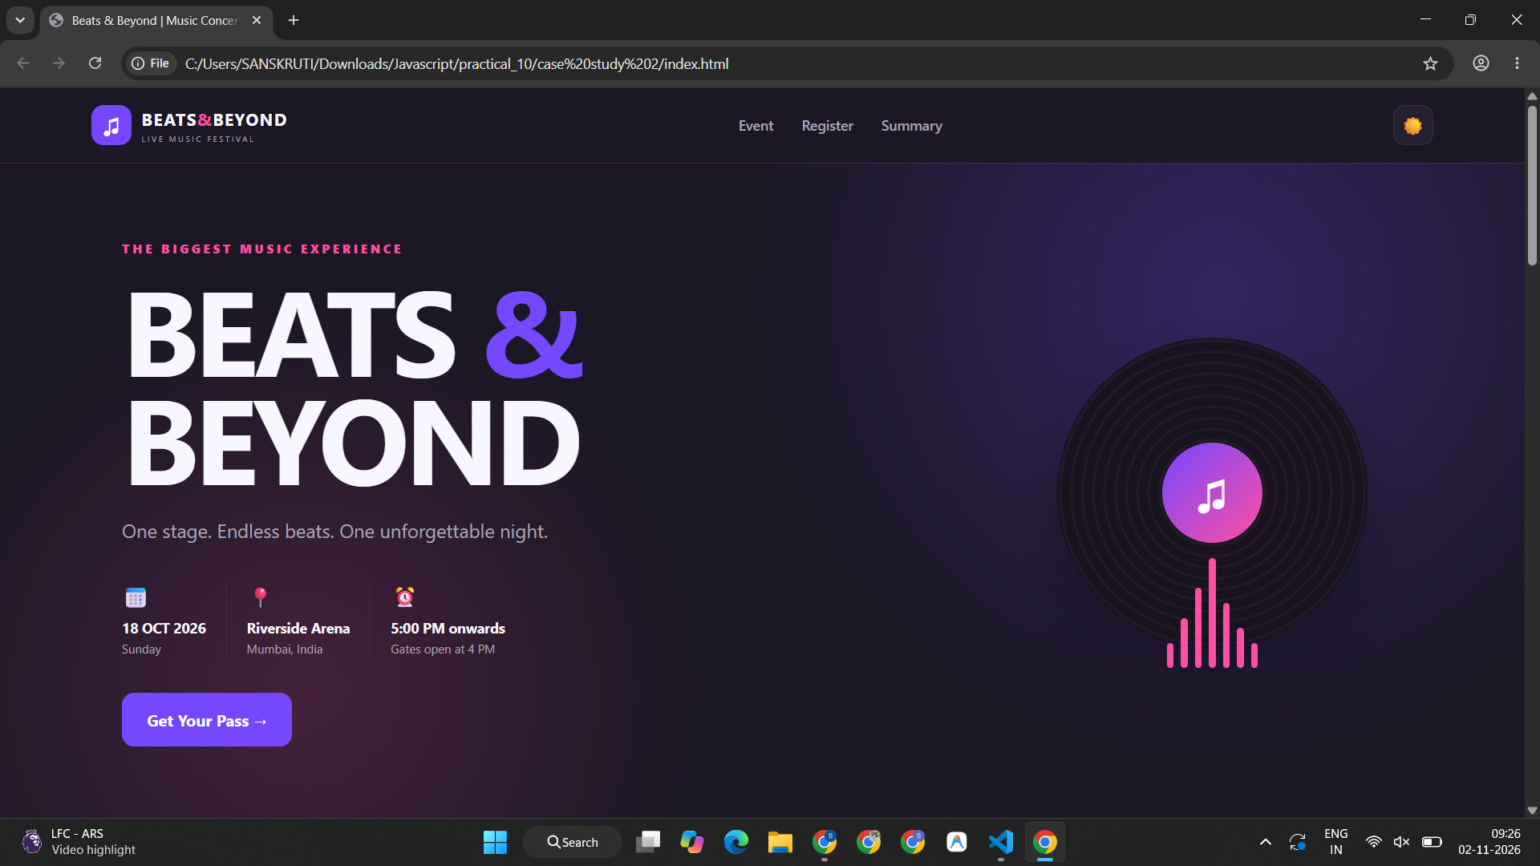
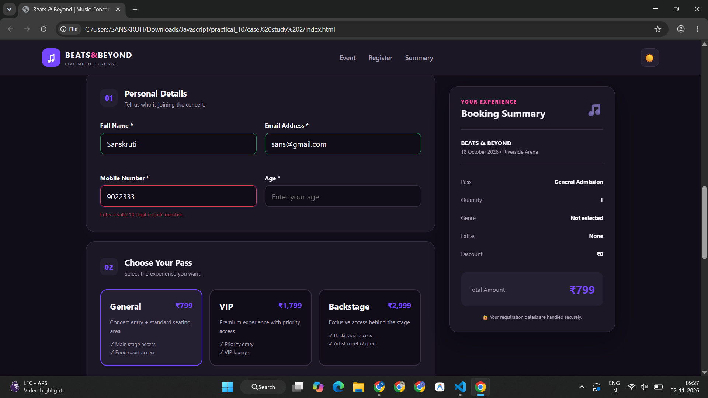
Additional Module: Discover Nagpur City Showcase (Blinking DOM Animations & Attractions)
index.html
<!DOCTYPE html>
<html lang="en">
<head>
<meta charset="UTF-8">
<meta name="viewport" content="width=device-width, initial-scale=1.0">
<title>Discover Nagpur | My City</title>
<link rel="stylesheet" href="style.css">
</head>
<body>

<!-- Navigation -->
<nav class="navbar">
<a href="#home" class="brand">NAGPUR<span>.</span></a>

<div class="nav-links">
<a href="#home">Home</a>
<a href="#about">About</a>
<a href="#landmarks">Landmarks</a>
<a href="#college">Education</a>
</div>

<a href="#landmarks" class="nav-button">Explore City ↗</a>
</nav>

<!-- Scrolling Message -->
<div class="announcement">
<div class="marquee">
🟠 WELCOME TO THE ORANGE CITY &nbsp; ✦ &nbsp;
EXPLORE THE BEAUTY OF NAGPUR &nbsp; ✦ &nbsp;
CULTURE, HERITAGE AND HOSPITALITY &nbsp; ✦ &nbsp;
WELCOME TO THE ORANGE CITY &nbsp; ✦ &nbsp;
</div>
</div>

<!-- Hero -->
<header class="hero" id="home">

<img
class="hero-image"
src="https://media.assettype.com/outlooktraveller/2024-02/dc94b0a8-5166-474a-a81e-7b75729a4d78/shutterstock_2314852377.jpg?ar=40%3A21&auto=format%2Ccompress&enlarge=true&mode=crop&ogImage=true&overlay=false&overlay_position=bottom&overlay_width=100&w=1200"
alt="Beautiful white dome of Deekshabhoomi in Nagpur"
>

<div class="hero-overlay"></div>

<div class="hero-content">
<span class="eyebrow">MAHARASHTRA, INDIA · 21.14° N</span>

<h1>My City.<br>
<span>Nagpur.</span>
</h1>

<p class="hero-description">
Where heritage meets modern life.
Discover the stories, landmarks and vibrant
culture of India's famous Orange City.
</p>

<a href="#landmarks" class="primary-button">
Discover Nagpur <span>→</span>
</a>

<div class="hero-caption">
<span class="caption-dot"></span>
A CITY FULL OF STORIES
</div>
</div>

<div class="hero-number">01 / MY CITY</div>
</header>

<!-- Quick Facts -->
<section class="facts">
<div class="fact">
<span class="fact-icon">🍊</span>
<div>
<h3>Orange City</h3>
<p>Famous for Nagpur oranges</p>
</div>
</div>

<div class="fact">
<span class="fact-icon">📍</span>
<div>
<h3>Central India</h3>
<p>A major city of Maharashtra</p>
</div>
</div>

<div class="fact">
<span class="fact-icon">🏛️</span>
<div>
<h3>Rich Heritage</h3>
<p>History, culture and landmarks</p>
</div>
</div>
</section>

<!-- About -->
<section class="about section" id="about">

<div class="section-label">01 — A LITTLE INTRODUCTION</div>

<div class="about-grid">
<h2>A city that feels<br>
<span>like home.</span>
</h2>

<div class="about-text">
<p>
Nagpur is one of Maharashtra's prominent cities,
known for its oranges, historical monuments,
educational institutions and welcoming culture.
</p>

<p>
From the peaceful dome of Deekshabhoomi to
the beautiful evenings at Futala Lake,
the city offers a wonderful mix of heritage,
nature and urban life.
</p>

<a href="#landmarks" class="text-link">
Explore the landmarks <span>↗</span>
</a>
</div>
</div>

</section>

<!-- Landmarks -->
<section class="landmarks section" id="landmarks">

<div class="landmark-heading">
<div>
<div class="section-label">02 — PLACES TO REMEMBER</div>
<h2>Explore the <span>city.</span></h2>
</div>

<p>
A few special places that make Nagpur memorable.
</p>
</div>

<div class="landmark-grid">

<!-- Deekshabhoomi -->
<article class="place-card place-large">

<div class="place-image">
<img
src="https://media.assettype.com/outlooktraveller/2024-02/dc94b0a8-5166-474a-a81e-7b75729a4d78/shutterstock_2314852377.jpg?ar=40%3A21&auto=format%2Ccompress&enlarge=true&mode=crop&ogImage=true&overlay=false&overlay_position=bottom&overlay_width=100&w=1200"
alt="Deekshabhoomi white stupa"
loading="lazy"
>
<span class="place-number">01</span>
</div>

<div class="place-info">
<div class="place-category">HISTORY & HERITAGE</div>
<h3>Deekshabhoomi</h3>
<p>
An important Buddhist monument associated
with Dr. B. R. Ambedkar and the historic
conversion to Buddhism in 1956.
</p>
<span class="place-tag">A symbol of equality</span>
</div>

</article>

<!-- Futala Lake -->
<article class="place-card">

<div class="place-image">
<img
src="https://dynamic-media-cdn.tripadvisor.com/media/photo-o/0a/a9/92/9e/beautiful-place.jpg?h=-1&s=1&w=1000"
alt="Futala Lake during sunset"
loading="lazy"
>
<span class="place-number">02</span>
</div>

<div class="place-info">
<div class="place-category">NATURE & LEISURE</div>
<h3>Futala Lake</h3>
<p>
A popular city destination known for its
lakeside views and evening atmosphere.
</p>
<span class="place-tag">Beautiful sunsets</span>
</div>

</article>

<!-- Zero Mile -->
<article class="place-card">

<div class="place-image">
<img
src="https://static.toiimg.com/photo/msid-91840727%2Cwidth-96%2Cheight-65.cms"
alt="Historic Zero Mile Stone in Nagpur"
loading="lazy"
>
<span class="place-number">03</span>
</div>

<div class="place-info">
<div class="place-category">HISTORY & LANDMARKS</div>
<h3>Zero Mile Stone</h3>
<p>
A historic survey monument built during
the British period in 1907.
</p>
<span class="place-tag">A historic marker</span>
</div>

</article>

<!-- Raman Science Centre -->
<article class="place-card">

<div class="place-image">
<img
src="./raman science.webp"
alt="Raman Science Centre and Planetarium"
loading="lazy"
>
<span class="place-number">04</span>
</div>

<div class="place-info">
<div class="place-category">SCIENCE & LEARNING</div>
<h3>Raman Science Centre</h3>
<p>
A science centre and planetarium that
encourages curiosity and learning.
</p>
<span class="place-tag">Explore and learn</span>
</div>

</article>

</div>
</section>

<!-- College -->
<section class="college-section" id="college">

<div class="college-content">
<div class="section-label">03 — EDUCATION & OPPORTUNITY</div>

<h2>Learning today.<br>
<span>Leading tomorrow.</span>
</h2>

<p>
Nagpur is home to several educational institutions
that bring students together to learn, innovate
and build their future.
</p>

<div class="college-highlight">
<div class="college-symbol">🎓</div>

<div>
<span class="college-caption">FEATURED INSTITUTION</span>
<h3 id="collegeName">Visvesvaraya National Institute of Technology</h3>
<p>VNIT Nagpur</p>
</div>
</div>

<p class="college-note">
The featured institution's name blinks to demonstrate
JavaScript DOM manipulation and CSS animation.
</p>
</div>

<div class="college-side">
<span class="side-number">03</span>
<span class="side-text">KNOWLEDGE · INNOVATION · GROWTH</span>
</div>

</section>

<!-- Final Banner -->
<section class="closing">
<span>THE ORANGE CITY</span>
<h2>Small moments.<br>
<em>Beautiful memories.</em>
</h2>
<a href="#home" class="primary-button">
Back to top ↑
</a>
</section>

<!-- Footer -->
<footer>
<a href="#home" class="brand footer-brand">NAGPUR<span>.</span></a>
<p>Designed with love for my city.</p>
<p class="copyright">
© <span id="year"></span> · My City Webpage
</p>
</footer>

<script src="script.js"></script>
</body>
</html>
style.css
@import url('https://fonts.googleapis.com/css2?family=DM+Sans:wght@400;500;600;700&family=Playfair+Display:wght@500;600;700&display=swap');

:root {
--navy: #142b3b;
--orange: #e77d35;
--cream: #f8f5ef;
--muted: #6f7779;
--white: #ffffff;
}

* {
margin: 0;
padding: 0;
box-sizing: border-box;
}

html {
scroll-behavior: smooth;
scroll-padding-top: 80px;
}

body {
background: var(--cream);
color: var(--navy);
font-family: 'DM Sans', sans-serif;
line-height: 1.7;
}

a {
text-decoration: none;
color: inherit;
}

img {
display: block;
width: 100%;
object-fit: cover;
}

/* NAVIGATION */

.navbar {
width: 100%;
min-height: 82px;
padding: 16px 6%;
display: flex;
align-items: center;
justify-content: space-between;
gap: 25px;
background: var(--cream);
}

.brand {
font-size: 25px;
font-weight: 700;
letter-spacing: -1px;
}

.brand span {
color: var(--orange);
}

.nav-links {
display: flex;
align-items: center;
gap: 32px;
}

.nav-links a {
font-size: 13px;
color: #46565f;
transition: color 0.2s;
}

.nav-links a:hover {
color: var(--orange);
}

.nav-button {
border: 1px solid #d5d0c6;
border-radius: 4px;
padding: 10px 17px;
font-size: 12px;
font-weight: 600;
transition: 0.25s;
}

.nav-button:hover {
background: var(--navy);
color: white;
}

/* SCROLLING TEXT */

.announcement {
overflow: hidden;
background: var(--navy);
color: white;
padding: 9px 0;
white-space: nowrap;
}

.marquee {
display: inline-block;
padding-left: 100%;
font-size: 11px;
font-weight: 600;
letter-spacing: 2px;
animation: marquee 24s linear infinite;
}

@keyframes marquee {
from {
transform: translateX(0);
}

to {
transform: translateX(-100%);
}
}

/* HERO */

.hero {
position: relative;
min-height: 590px;
width: 100%;
display: flex;
align-items: center;
padding: 75px 8%;
overflow: hidden;
background: #233b49;
color: white;
}

.hero-image {
position: absolute;
inset: 0;
width: 100%;
height: 100%;
object-fit: cover;
object-position: center 45%;
}

.hero-overlay {
position: absolute;
inset: 0;
background: linear-gradient(
90deg,
rgba(12, 27, 38, 0.94) 0%,
rgba(12, 27, 38, 0.77) 42%,
rgba(12, 27, 38, 0.15) 100%
);
}

.hero-content {
position: relative;
z-index: 2;
max-width: 660px;
}

.eyebrow {
color: #f6bb82;
font-size: 11px;
letter-spacing: 3px;
font-weight: 600;
}

.hero h1 {
font-family: 'Playfair Display', serif;
font-size: clamp(54px, 7vw, 94px);
font-weight: 600;
line-height: 1.06;
margin: 24px 0;
letter-spacing: -2px;
}

.hero h1 span {
color: #f6ae70;
font-style: italic;
}

.hero-description {
max-width: 470px;
color: #e2e6e6;
font-size: 15px;
line-height: 1.9;
margin-bottom: 30px;
}

.primary-button {
display: inline-flex;
align-items: center;
justify-content: center;
gap: 24px;
background: var(--orange);
color: white;
border-radius: 3px;
padding: 14px 21px;
font-size: 13px;
font-weight: 600;
transition: background 0.25s, transform 0.25s;
}

.primary-button:hover {
background: #cb6527;
transform: translateY(-2px);
}

.hero-caption {
display: flex;
align-items: center;
gap: 10px;
margin-top: 48px;
font-size: 10px;
letter-spacing: 2px;
color: #e5e7e8;
}

.caption-dot {
width: 8px;
height: 8px;
background: #f6ae70;
border-radius: 50%;
}

.hero-number {
position: absolute;
bottom: 28px;
right: 6%;
font-size: 10px;
letter-spacing: 2px;
color: white;
}

/* QUICK FACTS */

.facts {
display: grid;
grid-template-columns: repeat(3, 1fr);
padding: 30px 8%;
background: white;
border-bottom: 1px solid #e8e2d9;
}

.fact {
display: flex;
align-items: center;
gap: 15px;
padding: 12px 24px;
border-right: 1px solid #e7e1d9;
}

.fact:first-child {
padding-left: 0;
}

.fact:last-child {
border-right: none;
}

.fact-icon {
width: 45px;
height: 45px;
flex-shrink: 0;
border-radius: 50%;
display: grid;
place-items: center;
background: #fff0df;
font-size: 22px;
}

.fact h3 {
font-size: 14px;
font-weight: 700;
}

.fact p {
font-size: 11px;
color: var(--muted);
}

/* GENERAL SECTIONS */

.section {
padding: 95px 8%;
}

.section-label {
font-size: 10px;
letter-spacing: 2px;
font-weight: 700;
color: var(--orange);
}

/* ABOUT */

.about-grid {
display: grid;
grid-template-columns: 1fr 1fr;
gap: 70px;
margin-top: 22px;
align-items: start;
}

.about h2,
.landmark-heading h2,
.college-section h2,
.closing h2 {
font-family: 'Playfair Display', serif;
font-size: clamp(35px, 4vw, 52px);
line-height: 1.22;
font-weight: 600;
letter-spacing: -1px;
}

.about h2 span,
.landmark-heading h2 span {
color: var(--orange);
font-style: italic;
}

.about-text p {
font-size: 14px;
color: #667075;
margin-bottom: 16px;
line-height: 1.95;
}

.text-link {
display: inline-block;
margin-top: 10px;
padding-bottom: 4px;
border-bottom: 1px solid var(--orange);
font-size: 12px;
font-weight: 700;
}

.text-link span {
color: var(--orange);
margin-left: 8px;
}

/* LANDMARKS */

.landmarks {
background: #eeebe4;
}

.landmark-heading {
display: flex;
justify-content: space-between;
align-items: end;
gap: 30px;
margin-bottom: 40px;
}

.landmark-heading h2 {
margin-top: 12px;
}

.landmark-heading > p {
max-width: 270px;
font-size: 13px;
color: #697277;
line-height: 1.9;
}

.landmark-grid {
display: grid;
grid-template-columns: repeat(2, minmax(0, 1fr));
gap: 28px;
}

.place-card {
background: white;
overflow: hidden;
transition: transform 0.25s, box-shadow 0.25s;
}

.place-card:hover {
transform: translateY(-5px);
box-shadow: 0 15px 30px rgba(20, 43, 59, 0.09);
}

.place-image {
height: 300px;
overflow: hidden;
position: relative;
background: #d7d4cb;
}

.place-image img {
height: 100%;
transition: transform 0.45s;
}

.place-card:hover .place-image img {
transform: scale(1.04);
}

.place-number {
position: absolute;
left: 20px;
top: 20px;
width: 38px;
height: 38px;
border-radius: 50%;
background: white;
display: grid;
place-items: center;
font-size: 11px;
font-weight: 700;
}

.place-info {
padding: 25px 27px 29px;
}

.place-category {
color: var(--orange);
font-size: 9px;
letter-spacing: 2px;
font-weight: 700;
}

.place-info h3 {
font-family: 'Playfair Display', serif;
font-size: 27px;
margin: 8px 0 10px;
}

.place-info p {
color: #70787b;
font-size: 12px;
line-height: 1.9;
}

.place-tag {
display: inline-block;
margin-top: 18px;
padding: 5px 10px;
background: #f7f1e8;
color: #7c593b;
font-size: 10px;
border-radius: 2px;
}

/* COLLEGE SECTION */

.college-section {
display: grid;
grid-template-columns: 1.4fr 0.6fr;
min-height: 470px;
background: var(--navy);
color: white;
}

.college-content {
padding: 75px 10%;
}

.college-section h2 {
margin: 22px 0;
}

.college-section h2 span {
color: #f5b176;
font-style: italic;
}

.college-content > p {
max-width: 580px;
font-size: 13px;
line-height: 1.9;
color: #c8d1d5;
}

.college-highlight {
display: flex;
align-items: center;
gap: 18px;
margin-top: 30px;
padding: 22px;
max-width: 570px;
background: rgba(255, 255, 255, 0.08);
border: 1px solid rgba(255, 255, 255, 0.15);
}

.college-symbol {
width: 55px;
height: 55px;
flex-shrink: 0;
display: grid;
place-items: center;
background: #f6e8d7;
color: var(--navy);
border-radius: 50%;
font-size: 27px;
}

.college-caption {
color: #f5b176;
font-size: 9px;
letter-spacing: 1.5px;
}

.college-highlight h3 {
font-family: 'Playfair Display', serif;
font-size: 17px;
line-height: 1.4;
margin-top: 5px;
}

.college-highlight p {
font-size: 11px;
color: #d2dadd;
margin-top: 4px;
}

.college-note {
margin-top: 12px;
font-size: 10px !important;
color: #aab8bf !important;
}

.college-side {
background: linear-gradient(
135deg,
#d76c2d,
#efaa67
);
display: flex;
flex-direction: column;
justify-content: space-between;
padding: 45px;
color: white;
}

.side-number {
font-family: 'Playfair Display', serif;
font-size: 100px;
opacity: 0.75;
}

.side-text {
writing-mode: vertical-rl;
transform: rotate(180deg);
font-size: 10px;
letter-spacing: 3px;
font-weight: 700;
}

/* CLOSING */

.closing {
text-align: center;
padding: 90px 20px;
background: #f8f5ef;
}

.closing > span {
color: var(--orange);
font-size: 10px;
letter-spacing: 3px;
font-weight: 700;
}

.closing h2 {
margin: 20px 0 28px;
}

.closing h2 em {
color: var(--orange);
font-weight: 500;
}

/* FOOTER */

footer {
padding: 32px 6%;
background: #0d202d;
color: white;
display: flex;
align-items: center;
justify-content: space-between;
gap: 20px;
flex-wrap: wrap;
}

.footer-brand {
color: white;
}

footer p {
color: #c0c9cd;
font-size: 11px;
}

.copyright {
font-size: 10px;
}

/* RESPONSIVE DESIGN */

@media (min-width: 1500px) {
.hero {
min-height: 680px;
}

.section {
padding-left: 10%;
padding-right: 10%;
}
}

@media (max-width: 900px) {
.navbar {
padding: 18px 4%;
}

.nav-links {
gap: 15px;
}

.nav-button {
display: none;
}

.hero {
min-height: 530px;
padding: 60px 6%;
}

.facts {
padding: 25px 4%;
}

.fact {
padding: 10px;
}

.section {
padding: 70px 5%;
}

.place-image {
height: 250px;
}

.college-section {
grid-template-columns: 1fr 160px;
}

.college-content {
padding: 55px 7%;
}

.college-side {
padding: 30px 20px;
}

.side-number {
font-size: 70px;
}
}

@media (max-width: 600px) {
.navbar {
flex-wrap: wrap;
justify-content: center;
}

.brand {
width: 100%;
text-align: center;
}

.nav-links {
width: 100%;
justify-content: center;
flex-wrap: wrap;
gap: 18px;
}

.hero {
min-height: 560px;
padding: 55px 7%;
}

.hero-overlay {
background: rgba(12, 27, 38, 0.72);
}

.hero h1 {
font-size: 55px;
}

.hero-description {
font-size: 13px;
}

.facts {
grid-template-columns: 1fr;
padding: 20px 7%;
}

.fact,
.fact:first-child {
padding: 14px 0;
border-right: none;
border-bottom: 1px solid #e7e1d9;
}

.fact:last-child {
border-bottom: none;
}

.about-grid {
grid-template-columns: 1fr;
gap: 25px;
}

.landmark-heading {
flex-direction: column;
align-items: start;
}

.landmark-grid {
grid-template-columns: 1fr;
}

.place-image {
height: 250px;
}

.college-section {
grid-template-columns: 1fr;
}

.college-content {
padding: 55px 7%;
}

.college-side {
min-height: 130px;
flex-direction: row;
align-items: center;
}

.side-number {
font-size: 60px;
}

.side-text {
writing-mode: initial;
transform: none;
font-size: 8px;
}

footer {
flex-direction: column;
text-align: center;
}
}

/* Respect reduced-motion preferences */
@media (prefers-reduced-motion: reduce) {
*,
*::before,
*::after {
animation-duration: 0.01ms !important;
scroll-behavior: auto !important;
transition-duration: 0.01ms !important;
}
}
script.js

// 1. College name blinking effect
const collegeName = document.getElementById("collegeName");

if (collegeName) {
collegeName.classList.add("blink");

// Toggle visibility through JavaScript
setInterval(function () {
collegeName.style.visibility =
collegeName.style.visibility === "hidden"
? "visible"
: "hidden";
}, 700);
}

// 2. Automatically update the footer year
document.getElementById("year").textContent =
new Date().getFullYear();

// 3. Handle image-loading errors
document.querySelectorAll("img").forEach(function (image) {
image.addEventListener("error", function () {
image.style.display = "none";

const parent = image.parentElement;

if (parent) {
parent.style.background =
"linear-gradient(135deg, #d9c8b5, #8c9da0)";
}
});
});

// 4. Welcome message
console.log("Welcome to Discover Nagpur!");
Output –
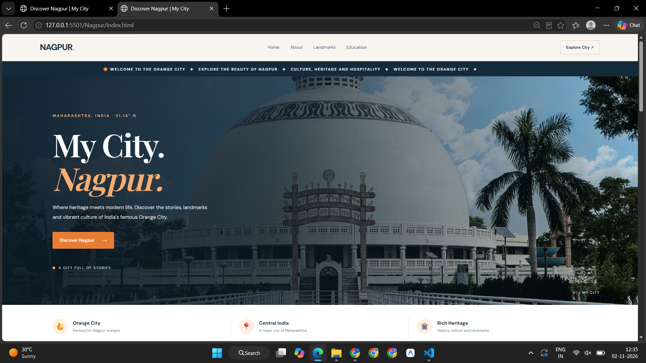
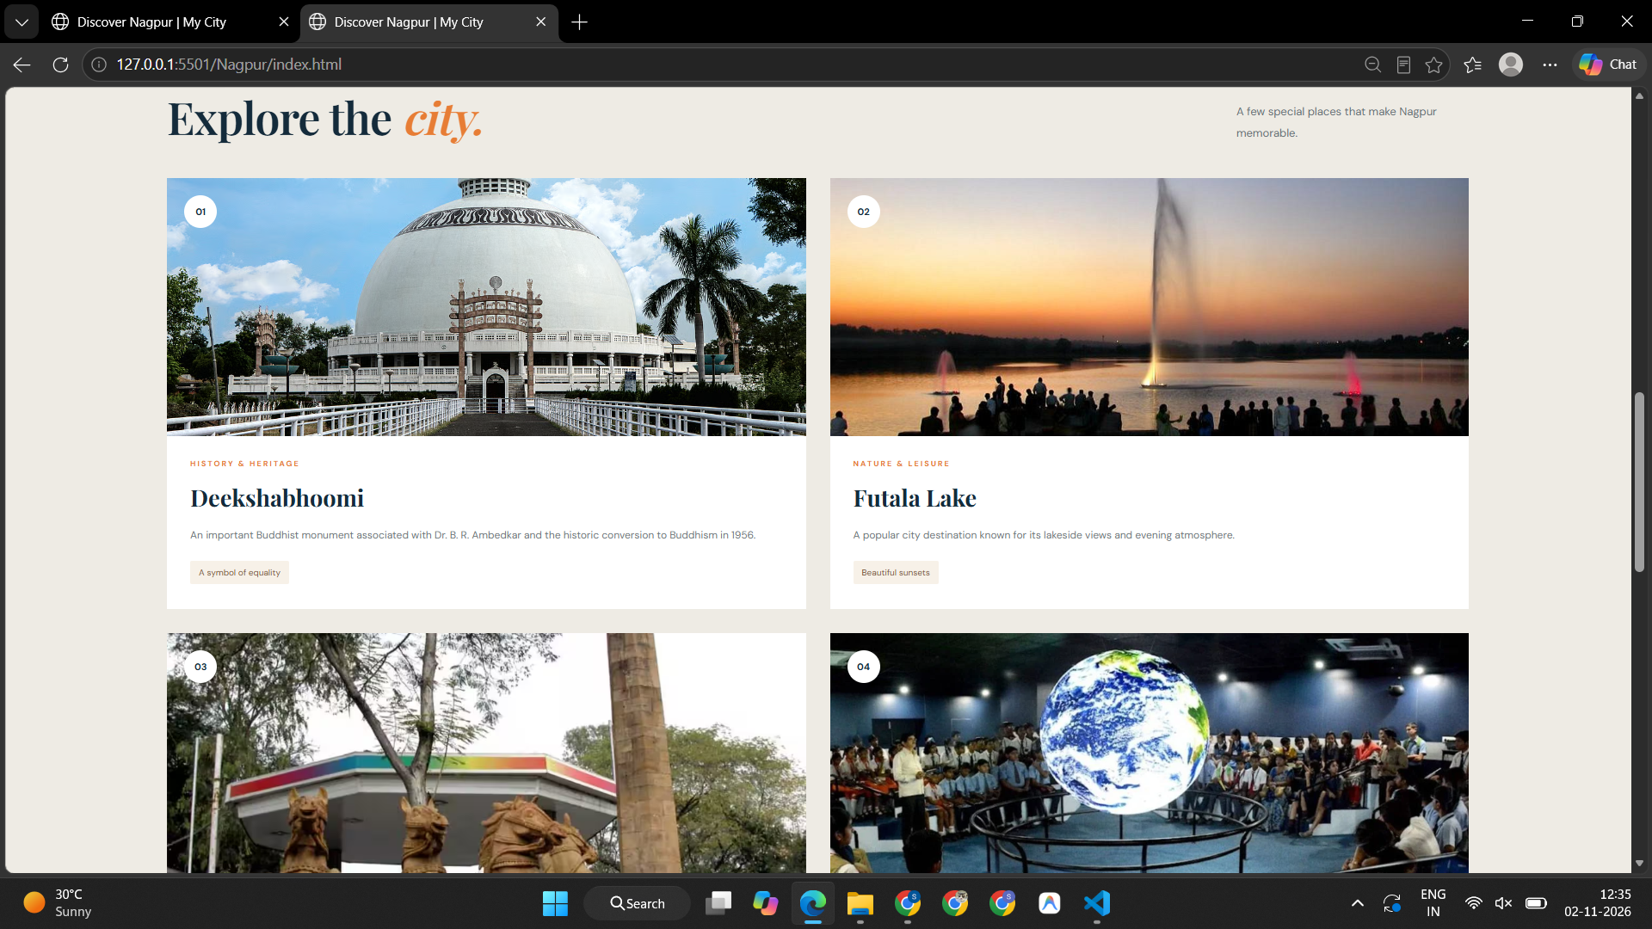
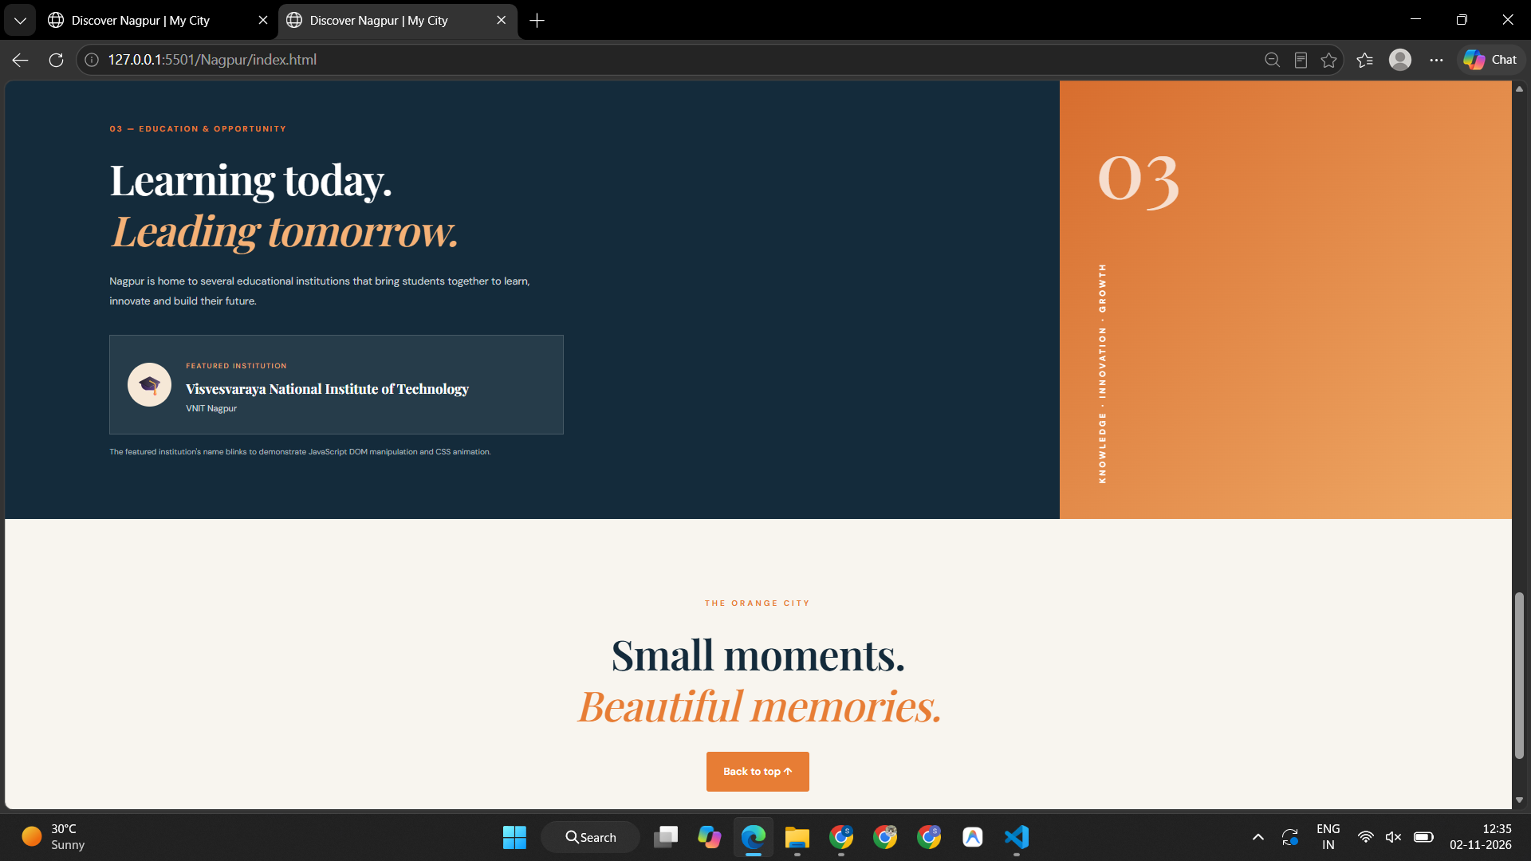
Conclusion –
In this experiment, the jQuery framework and HTML5 Web Storage (localStorage) were effectively used to create interactive and stateful web applications. The Interactive Task Manager demonstrated simplified DOM event handling, dynamic HTML creation, item completion toggling, and seamless persistence across page reloads. Case Study 2 (Beats & Beyond) showcased advanced multi-tier ticket booking with real-time summary calculation, discount coupon handling, and robust form validation. Additionally, the Discover Nagpur module illustrated JavaScript setInterval animation effects, class toggling, and responsive card layouts. All implementations were tested and executed successfully.

